Life Savers  
  
Not just another day at the beach

Contents

Product Overview 2

**Moral Argument** 2

**Description** 2

**Unique Selling Points** 2

**Target Market** 2

**Design Pillars** 2

**Mechanics and Systems** 4

**Controls** 6

**Key Characters** 6

**Revision History**

|  |  |  |
| --- | --- | --- |
| **Version** | **Date** | **Details** |
| 0.1 | 23.04.2021 | Initial Document |
| 2.0 | 13.05.2021 | Changed content based on feedback |
|  |  |  |
|  |  |  |
|  |  |  |
|  |  |  |
|  |  |  |

# Product Overview

## **Moral Argument**

Saving lives on the beach of Bondi takes more than just stamina

## **Description**

*Life Savers* is a life management sim, where you manage the mental health and stamina of your life saving team in Bondi Beach Life Savers Club.

**Details**

* Players: Single Player
* Genre: Management style game / Isometric
* Platform: PC

## **Unique Selling Points**

* A closer look at the inner workings of the Lifesaving volunteers of Australia
* Beach culture aesthetics
* Diorama art style

## **Target Market**

* Casual players
* Players that enjoy a level of micromanagement

## **Design Pillars**

* Emotional, Physical and Mental Stress management
  + Manage each volunteer’s health (Mental and Fitness)
* State Management
  + Volunteers will change states (Patrol and Reaction) based on their health

**Game Loop**

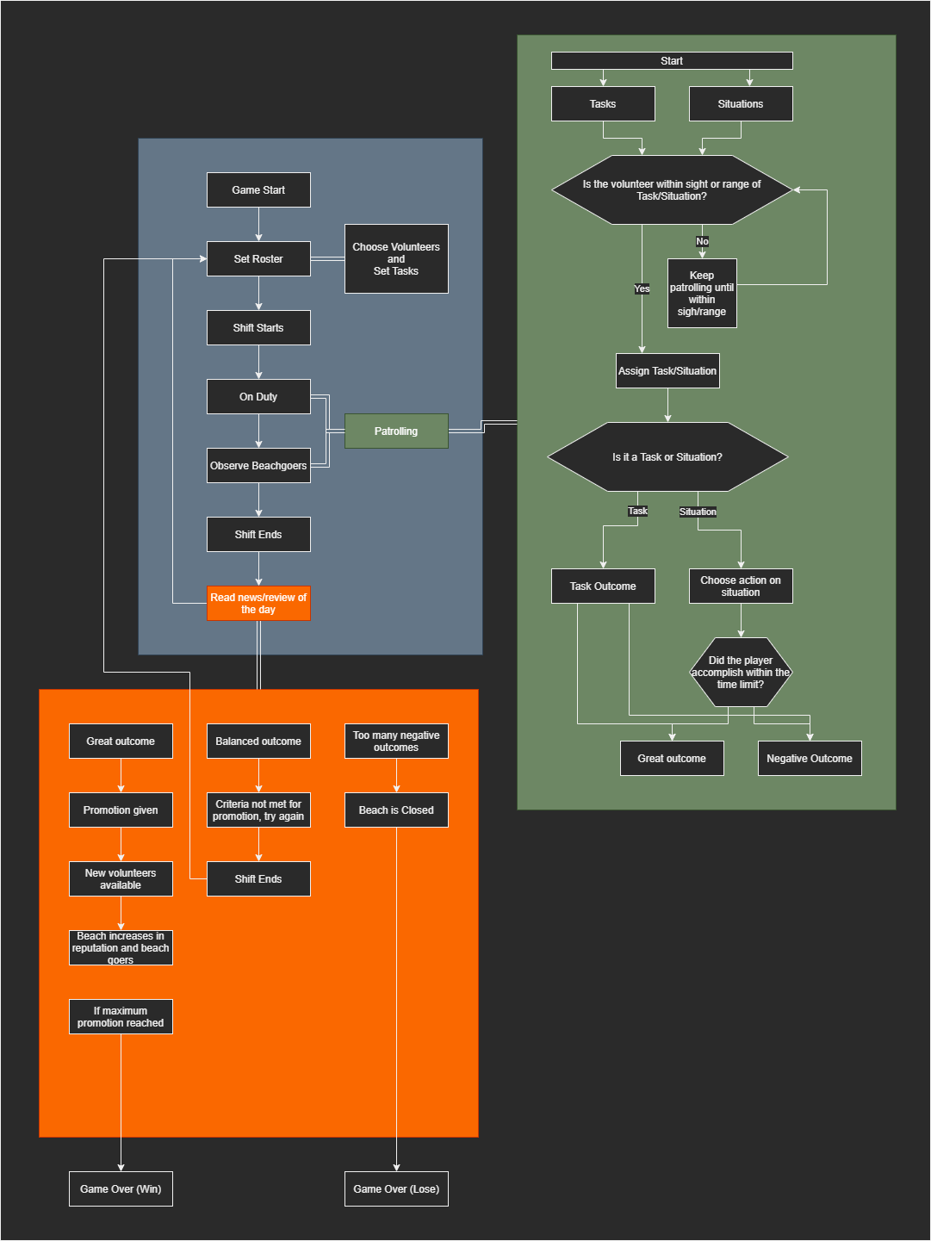

# **Mechanics and Systems**

* Movement & Camera
  + Scene transitions between areas (beach, roster, office, sea/ocean)
  + Movements are scripted to demonstrate outcomes of the states of the characters
    - It will be a point and click system for movement overall.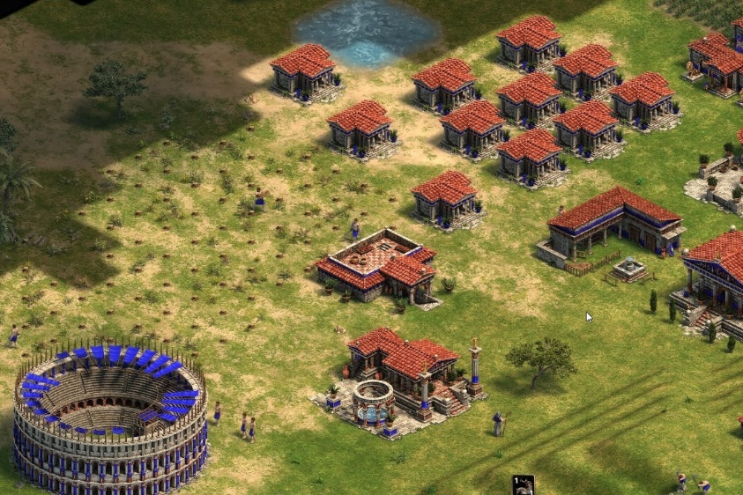

Mouse pointer to indicate where to move

Figure 1 Age of Empires; Demonstrates the Camera view as well.

* Notifications
  + Notifications occur if there are moment that players need to address, from stressed (breakdown moments) to situations happening at the oceans (drowning, altercations)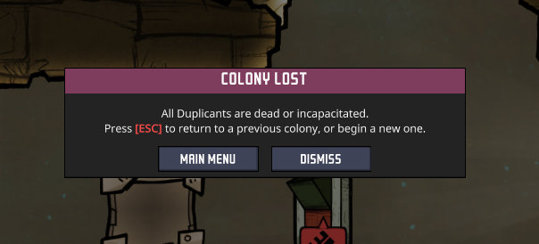

Figure 2Oxygen Not Included: Notifications prompt

* Menu
  + Simple menu system that allows play, pause, sound control

Roster

* + Players ability to assign and change the roster of the volunteers that work, whether they need a break and be replaced by someone fresh, or to assign a task to a well skilled volunteer

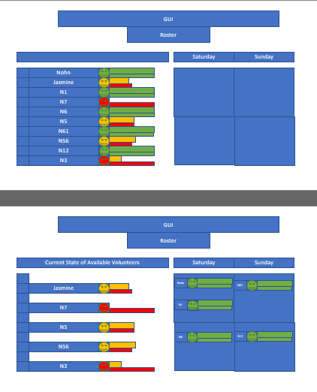

Figure 3 Basic Roster Layout

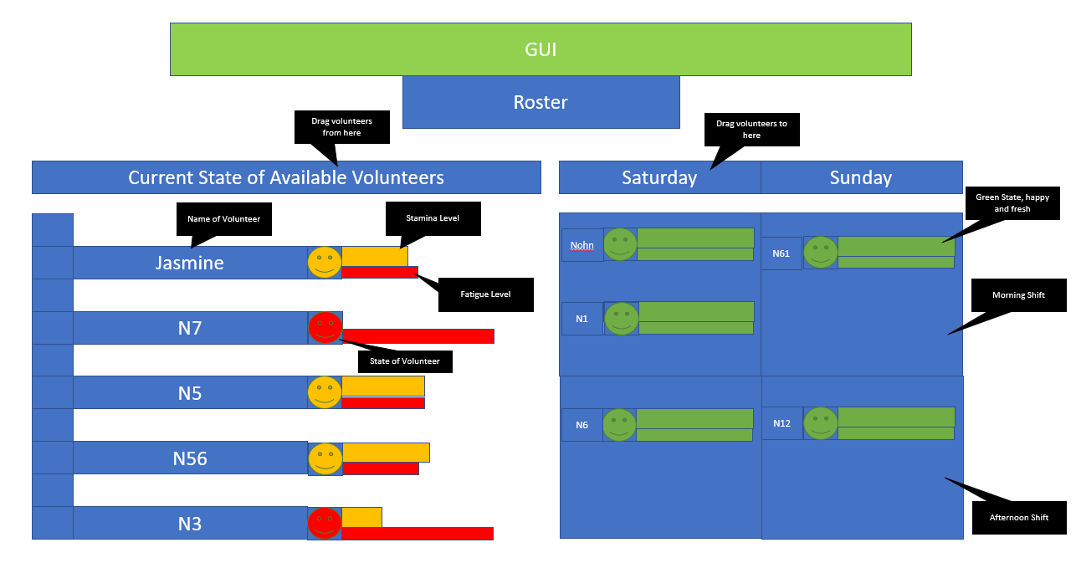

Figure 4 Roster with tags, provided in wireframe doc.

* State System
  + Idle, Patrolling, or performing a task, this will be dependant on the circumstances and events of the team members and will dictate their actions as a result
  + Each state will rely on how healthy and how functional the volunteers are, if they are not taken off the roster to recover, they change into stressed and fatigued states while on duty
* Equipment usage system
  + Team members can use the available equipment (buggy, life saving board) to better manage their Stamina and mental health meters if available

# **Controls**

* PC
  + Mouse controls to react to notifications and drag and drop volunteers into a proper position for the roster, essentially interacting with the UI
  + The mouse also controls the movement of each character, pointing to where a character needs to be.

# **Key Characters**

* Manager
  + The player, who manages the roster and assigns volunteers the tasks
* The Volunteers
  + 5 Volunteers to manage, each with their own personalities
    - Example One: The go getter and ego driven volunteer that from time to time may disobey a task to do another one instead.
    - Example Two: The lazy one where some tasks may be performed based on their cost
    - Example Three: The almost perfect volunteer, does all the tasks and well, but gets fatigued and stressed easily

**Player Progression**

* At the passing of each day/week, a report comes up with reviews of the volunteer’s morale.
  + If a volunteer’s morale is very low, there is likely a chance that they could quit or cause and incident.
  + If a volunteer’s morale is high, they perform better
* There are news of any incidents and reflect how positively or negatively dealt with depending on players choices
  + The news reflect the rating of your job and could lead to promotions and bonuses or demotions, penalties and eventual firing (losing the game)

**Level Design**

Simple Environment of a shot of the beach, a shot of an office and an image of a roster

* Bondi Beach
  + The level is a shot of Bondi Beach in which the volunteers act and react to what happens there

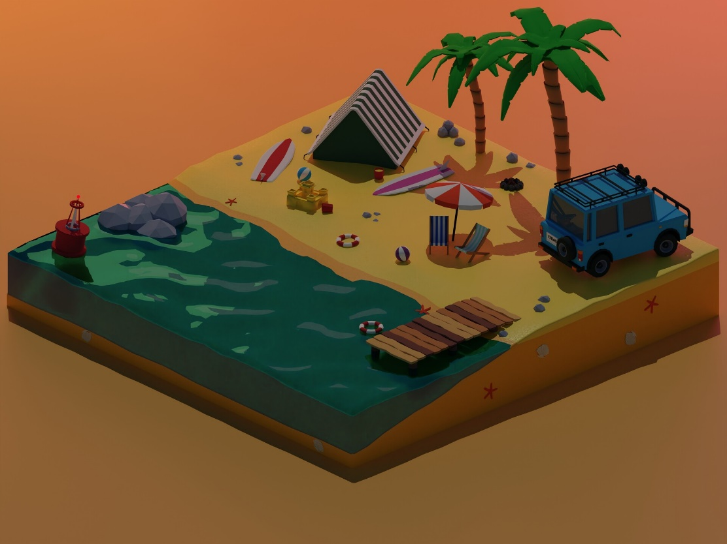

Figure Mouse icon indicating where to click, and volunteers (bodies to be added later) to manage

* Office
  + The are in which the player can decide what to organise, from the roster to the equipment allocation and crew evaluation, review and reports to make an informed decision as to how the volunteers will work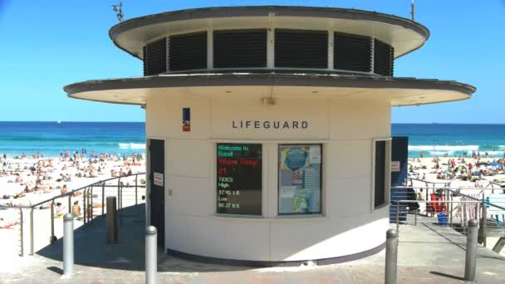 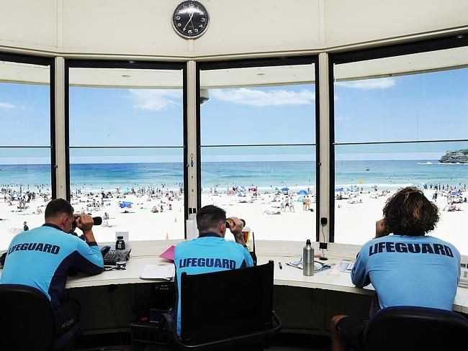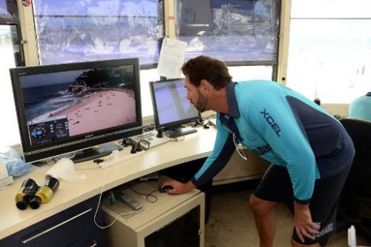

**Themes and Story**

It is the first day of managing a volunteer life saver club at Bondi, the themes are beach, sunny days for the most part, patrons at risk of drowning, or curbing poor behaviour, like litter and graffiti etc.

As the days progress you take care of your volunteers and make sure the rotations based on the days roster are well balanced and that the proper crew are on duty and the ones that are resting are taking some time off, be ready for anything, a bad day can mean life and death for the tourists and visitors of Bondi Beach and ultimately you being fired.

If you manage through a year and if the people rejoice at how well you have handled, you should now be running the safest and happiest Beach in Australia, dare say… the world.

**The Story**

The story is the player is hired to manage the volunteer crew and maintain a good working environment that takes care of the welfare, physically and mentally of each of the unique members.

* Manager the health of your volunteers by rotating through the roster
* Create a safe environment for everyone to raise your reputation to earn promotions and bonuses
* Learn more about the strength and weaknesses of your volunteers as they perform tasks and deal with stressful situations

**Art Style and Aesthetic**

* Colour Palette

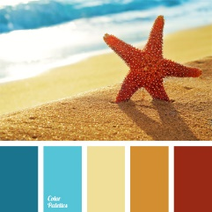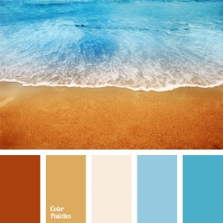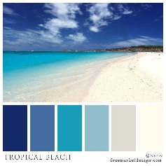

* Character Art Style

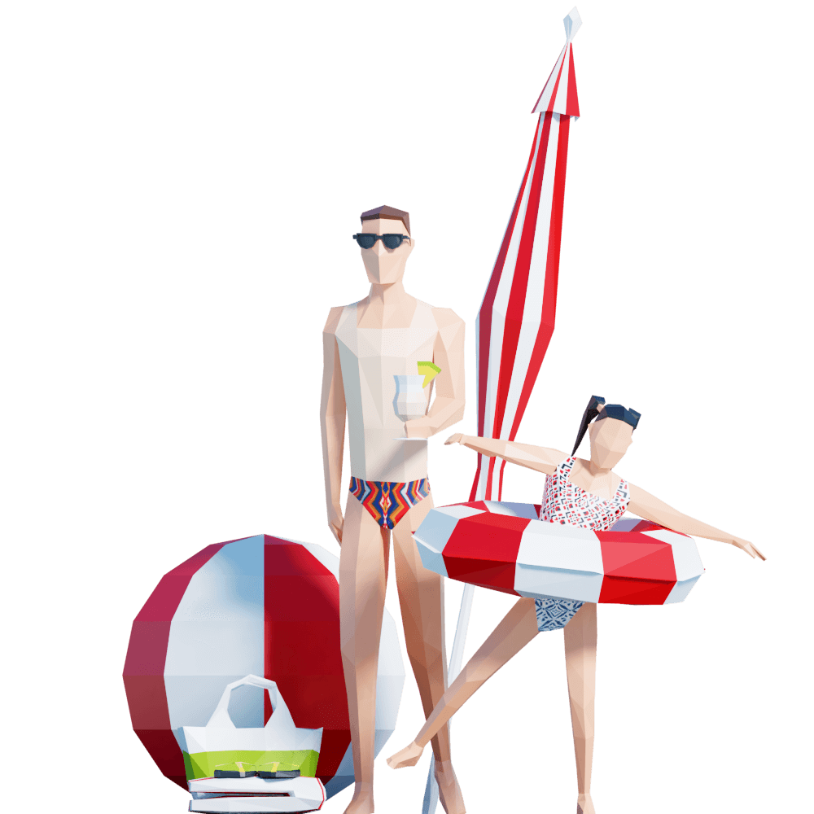

* Environmental Art Style

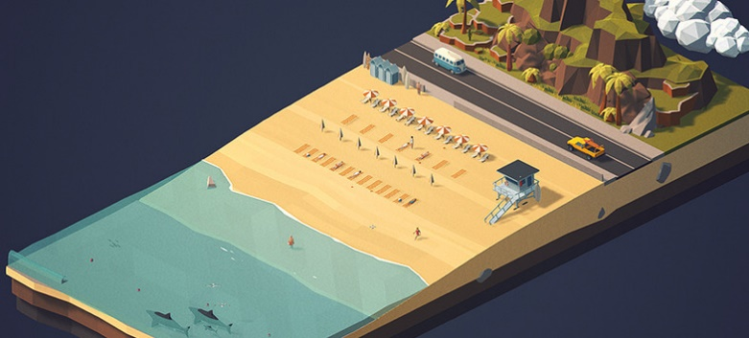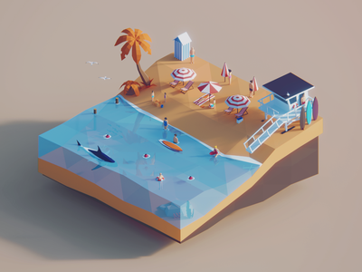

* Lighting

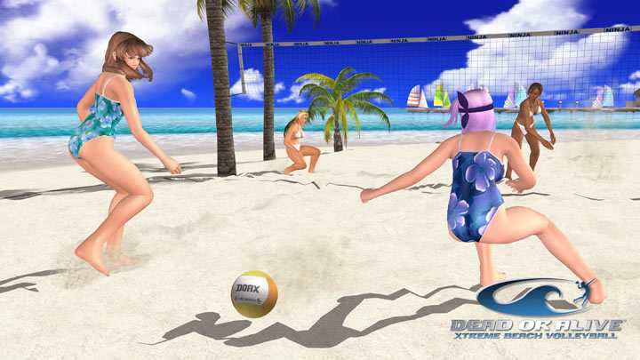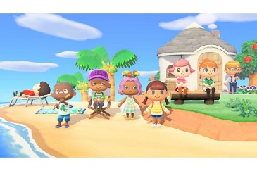

**Sound**

* Music (Music will change depending on the mode (Office/Beach) and circumstances (Chill no events / Hectic dramatic action)
  + Chiptunes style of music (Synthwave, Retro Chill)
    - Highway Superstar – Skylines
    - Slumber – Qwerty Woman
    - City Limits – Lakey Inspired
  + Chillout Lounge Style as an alternative
* SFX
  + Beach Waves
  + Crowd sound
  + Water
  + Running
  + Paper Rustling (Roster)
  + Click/Typing sounds (emulating using a computer to set tasks)
  + Crowd yells (when a shark is spotted or drowning)
  + Emergency Alarm